Annex 4
To the question №51/22_19

Approved
by the Board of the RCC CAs Heads
Decision №49/20-18 of 15-16.07.2014

REGULATIONS
on Rewards of the Regional Commonwealth in the field of Communications

- In order to encourage the enterprises, institutions, public and other organizations, their employees and labor groups who have made a significant contribution in the creation and ongoing development of the Regional Commonwealth in the field of Communications (hereinafter - RCC), raising its international authority and strengthen the role of the RCC in the field of postal and telecommunications services, improving interaction between the RCC and international and regional organizations, the expansion of mutually beneficial cooperation in the interests of the RCC participants and Coordination Council of the CIS member states for Informatization
attached to RCC (hereinafter - the Coordination Council), as well as other deserts to RCC established the following awards of the RCC:

- Order of the Regional Commonwealth in the field of Communications (hereinafter – Order, Annex 1);
- Medal of the Regional Commonwealth in the field of Communications (hereinafter – Medal, Annex 1);
- Certificate of Honor of the Regional Commonwealth in the field of Communications (hereinafter – Certificate of Honor, Annex 2);
- Diploma of the Regional Commonwealth in the field of Communications (hereinafter – Diploma, Annex 3).
2. Conditions of the promotion:
2.1. By Order can be awarded Chairman of the RCC Board of the Communications Administrations Heads (hereinafter - the RCC CAs Board) and the Coordinating Council, whose functions are performed by Heads of communications administrations, as well as for long-term fruitful cooperation with the RCC and extra deserts to the RCC - other Heads
of communications administrations - members of the RCC , Heads of international and regional organizations which actively involved at the RCC activities, and the Director General of the RCC Executive Committee (hereinafter - the RCC Executive Committee).
2.2. By Medal can be awarded Heads of the communications administrations that are members of the RCC and their Deputies, members of the Coordinating Council, Heads of sectoral international and regional organizations which actively involved at the RCC activities, and their Deputies, as well as the Director General of the RCC Executive Committee and its Deputies.
2.3. By Certificate of Honor can be awarded employees and work teams
of communications administrations, communications operators, sectoral research institutions, educational institutions, international and regional organizations involved at the RCC activities, employees of the RCC Executive Committee and the members of the Coordinating Council.
2.4. By Diploma can be awarded the persons listed in item 2.3 above, as well as other citizens of the RCC Member States.
3. Presentation to the award and the decision to award
3.1 The decision on awarding of Orders, Medals and Diplomas is made by the Board of the RCC CAs Heads on the proposal of the RCC Communications Administrations Heads – the RCC participants, the RCC Board and the Coordination Council Chairmen and Deputy Chairmen, Chairmen of the RCC Operators Boards and RCC Commissions, as well as the Director General
of the RCC Executive Committee.
3.2 The presentation for promotion by the Order, the Medal and the Certificate of Honor is sent to the Chairman of the RCC Board and contains the following information: surname, name, patronymic and name of the position of the candidate for promotion; information about the achievements submitted to the promotion.
3.3 The RCC Executive Committee prepares the necessary documents for consideration of the submitted candidates at the next meeting of the RCC Board.
3.4 The decision on awarding the Diploma is made by the Director General of the RCC Executive Committee on the proposal of the communications administrations - RCC participants and other public authorities of the RCC member states, RCC working bodies, the RCC Executive Committee, as well as heads of enterprises, institutions, public and other organizations.
3.5 The nomination of a candidate for the award by the Diploma is submitted for consideration by the Director General of the RCC Executive Committee, certified by the signature of the head and the seal of the organization and contains the following information: the full name of the organization; surname, name, patronymic and name of the position of the head of the organization and candidates for promotion; information about the achievements submitted to the promotion; organization contact phone number
4. Award procedure
4.1 Awarding is made in the following order:
- The Order is presented by the Chairman of the RCC Board, the Deputy Chairman of the RCC Board or the Director General of the RCC Executive Committee;
- The Medal is presented by the Chairman of the RCC Council, the Deputy Chairman of the RCC Council, the Chairman of the Coordination Council, the Deputy Chairman of the Coordination Council, the Head of Communication Administration of the RCC participant or the Director General of the RCC Executive Committee;
- The Certificate of Honor is signed by the Chairman of the RCC Board and is awarded by the Chairman of the RCC Board, the Deputy Chair of the RCC Board, the Chairman of the Coordination Council or his deputy, the head of the communications administration of the RCC participant or the Director General of the RCC Executive Committee;
- The Diploma is signed by the Chairman of the RCC Council or by the Director General of the RCC Executive Committee and is awarded by the Director General of the RCC Executive Committee.
5.Final Regulations
5.1. By decision of the organization that submitted the nominee for the award, the RCC award may be awarded with a memento. The cost of the gift is determined in accordance with the requirements of applicable national law. The acquisition of a memento for the award is made by the organization that submitted the nominee for the award.
5.2. Information on the awarding is placed by the RCC Executive Committee on the RCC official website on the Internet and may be published in the media, published by the RCC.
5.3. Accounting and registration of RCC incentives, as well as accounting and storage of Orders, Medals, Forms of Certificates of Honor and Diplomas is carried out by the RCC Executive Committee.

Annex 1
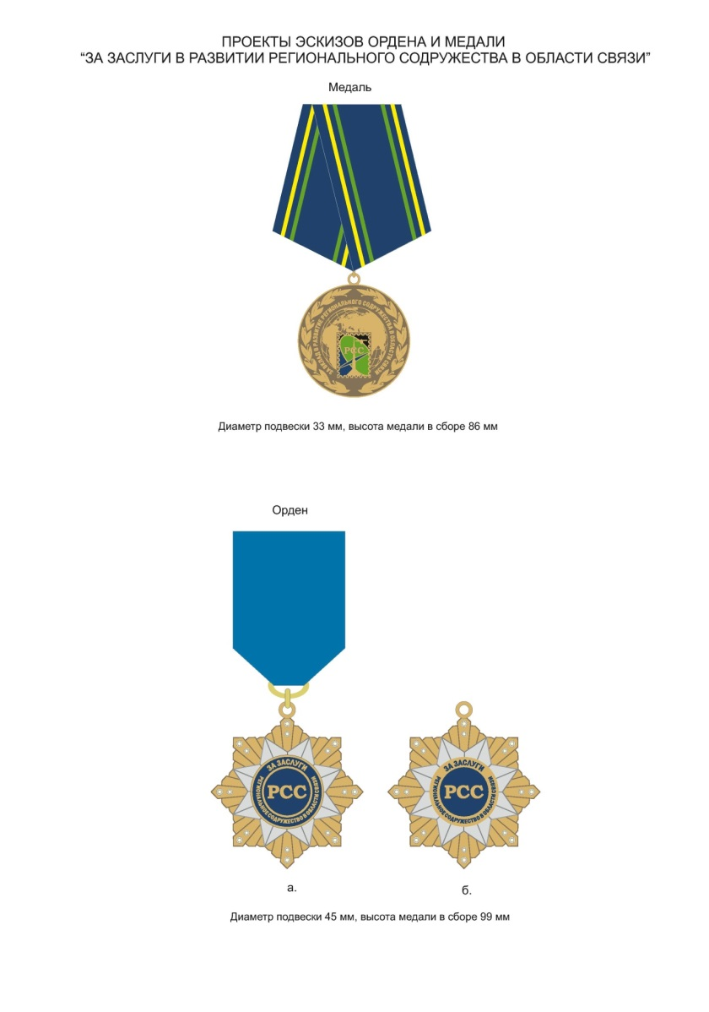

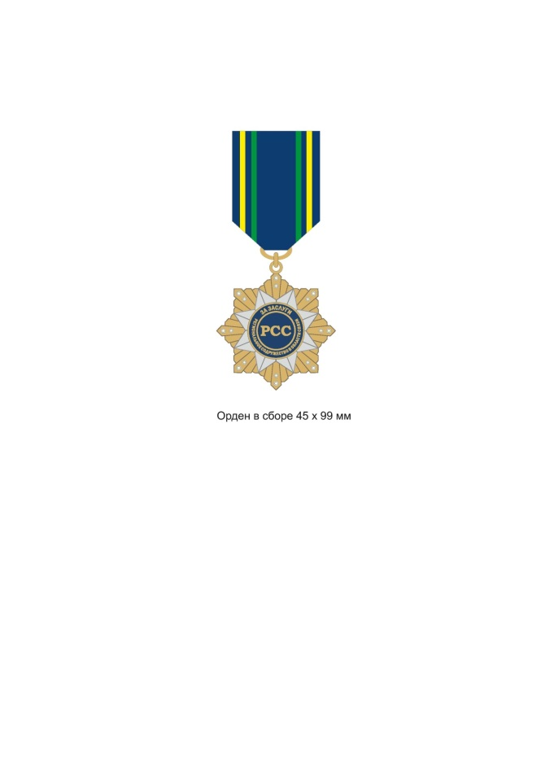

Annex 2
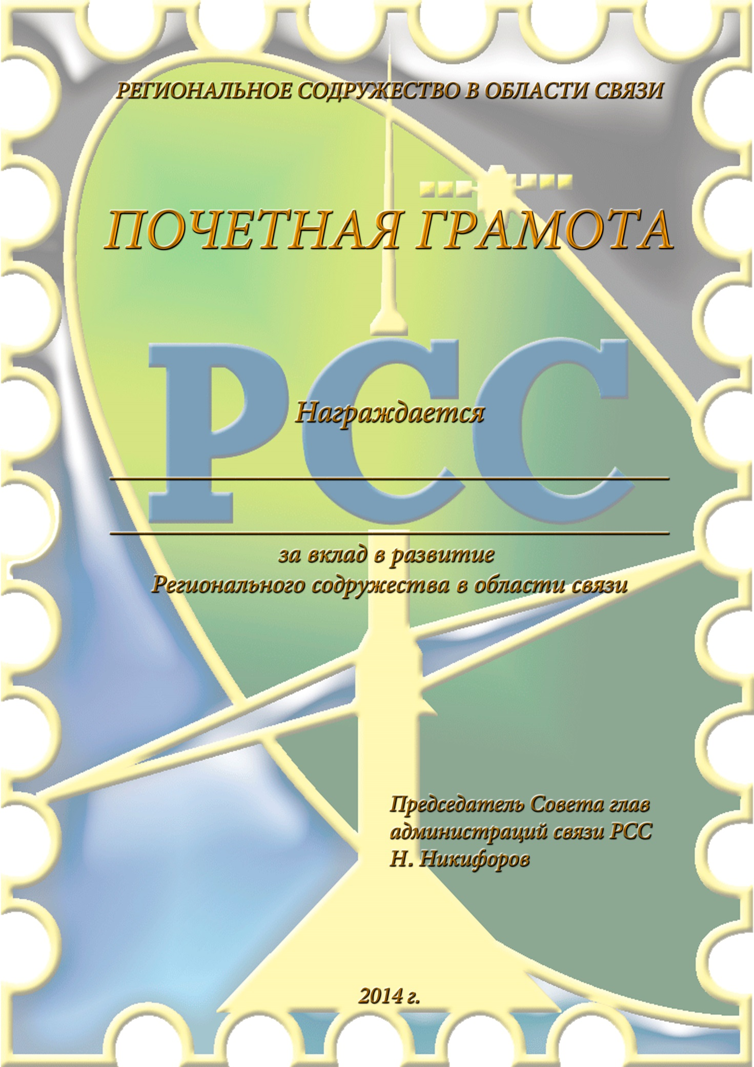

Annex 3.1
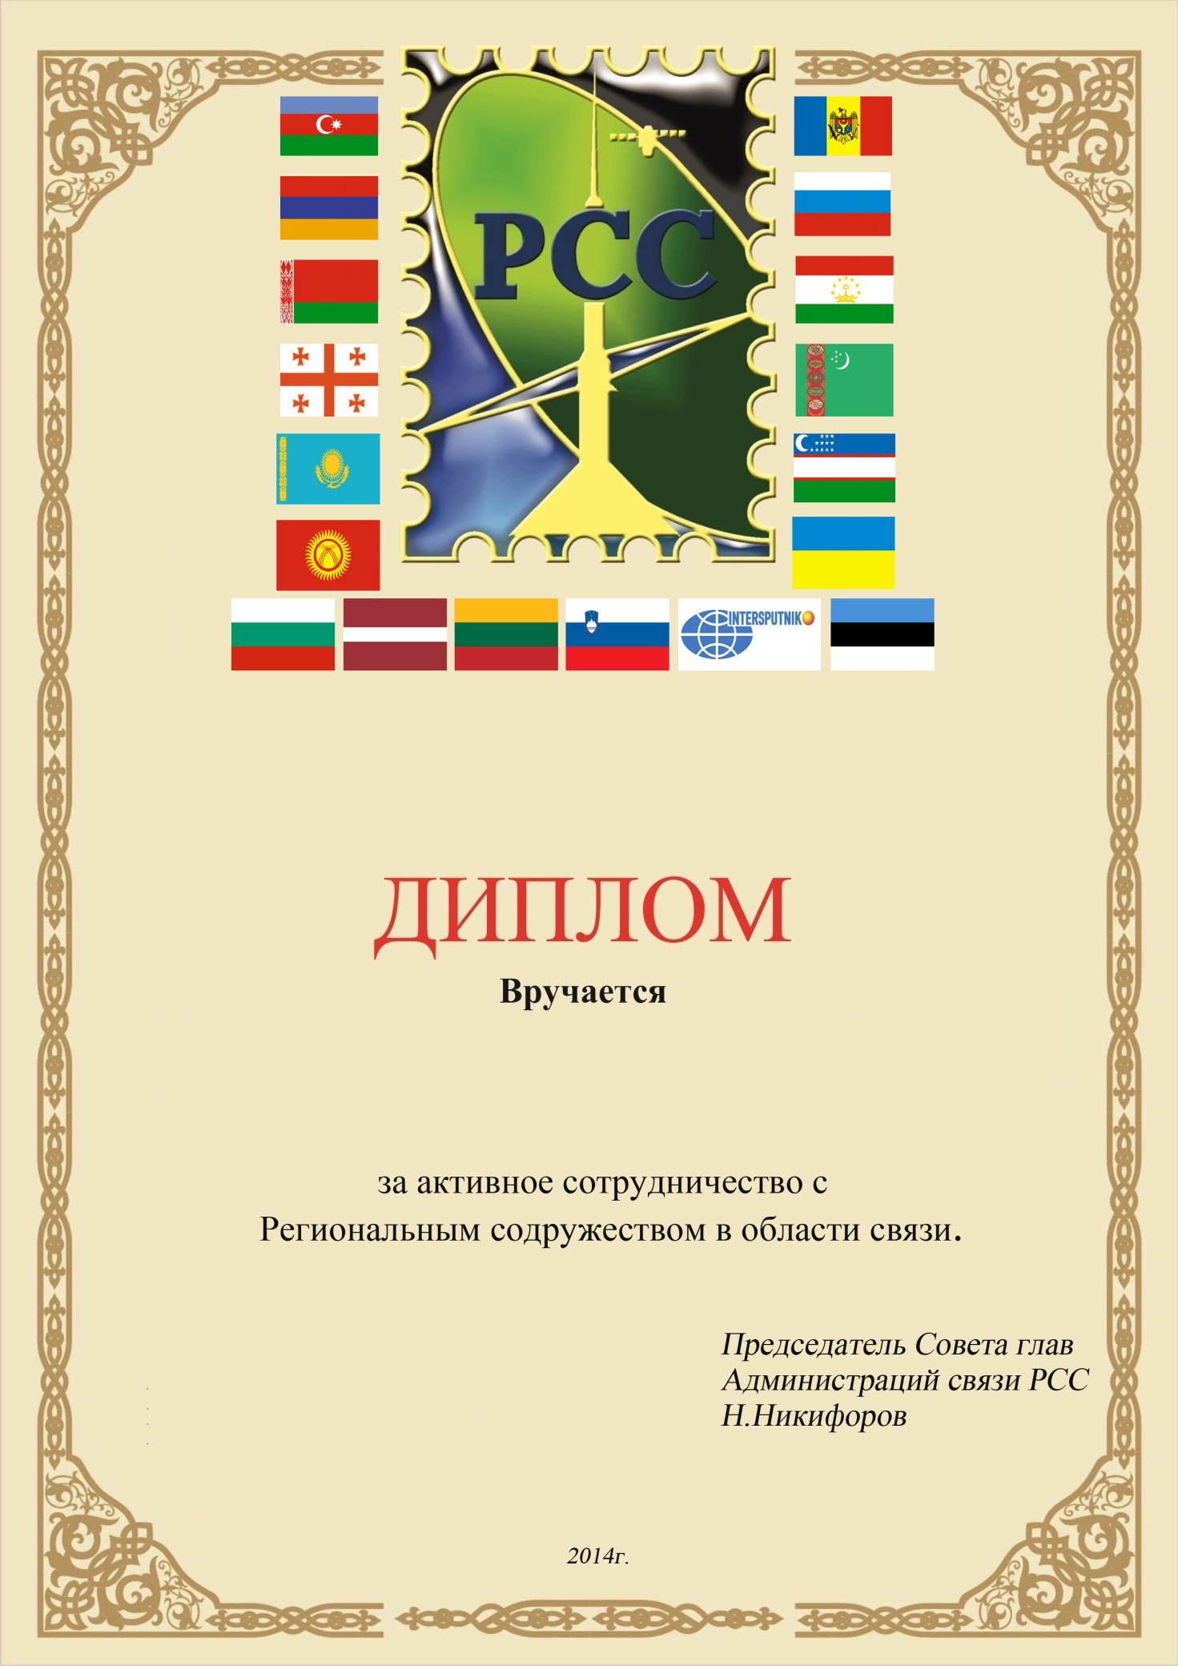

Annex 3.2
