REGIONAL COMMONWEALTH IN THE FIELD OF COMMUNICATIONS (RCC)
BOARD OF THE COMMUNICATIONS ADMINISTRATIONS
COORDINATION COUNCIL OF THE CIS MEMBER-STATES ON THE INFORMATIZATION AT THE RCC

Decision № 55/25-3
16-17 September 2019 г. Protocol N2 55/25
About the measures taken in the countries of the RCC participants to combat fraud on communication networks
Having heard information on the matter, given the international nature of the problems of combating fraud in telecommunication networks, taking into account the specific subject matter of the fraud, and the necessity of legal provision of cooperation in this sphere at the governmental level, to implement Decisions of the RCC Board of the CAs Heads № 253/24-16 from 9-10 October 2018, Ashgabat, Turkmenistan,

The Heads decided:
- Consider it appropriate to send the draft Memorandum on countering fraud in telecommunications networks to the CIS Executive Committee for consideration by the CIS higher authorities in the prescribed manner.
- Instruct the RCC Executive Committee to continue its work on supporting the consideration by the CIS higher authorities of the draft Memorandum on countering fraud in telecommunications networks.
З. Request the RCC CA to send information to the RCC Executive Committee by December 1, 2019 on specific measures taken in their countries to combat fraud on communication networks.
- Instruct the RCC Executive Committee to summarize the information received from the RCC AC and submit it to the RCC telecommunication and infocommunication operators board of the for consideration.
- To instruct the RCC telecommunication operators board about the measures undertaken in the countries of the RCC members on the fight against fraud on communication networks, to report at the regular joint meeting of the Board of the RCC CAs Heads and Coordination Council for Informatization at the RCC.

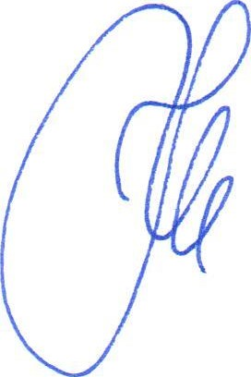
Nur-Sultan
Chairman
K.Yu. Noskov

