REGIONAL COMMONWEALTH IN THE FIELD OF COMMUNICATIONS (RCC)
BOARD OF THE COMMUNICATIONS ADMINISTRATIONS
COORDINATION COUNCIL OF THE CIS MEMBER-STATES ON THE INFORMATIZATION AT THE RCC

Decision № 55/25-2
16-17 September 2019 Protocol N2 55/25
About the prospects of 5G technology development in the countries of the RCC members
Having heard and discussed information on this issue, emphasizing the key role of ITU in regulating such a limited resource as the radio frequency spectrum, taking into account that the potential inherent in 5G technologies provides conditions for long-term digital transformation and contributes to the development of the information society in the RCC member countries, taking into account that in the near future the task is to balance the needs for 5G spectrum and 3G and 4G services that continue to be deployed in the market of the countries of the RCC member,
The Heads decided:
- Take note of the information on the development of 5G technology in the countries of the RCC member.
- Recommend that the RCC communications administrations, taking into account the strategy and the leading role of ITU in the regulation of radio frequency spectrum, continue to work at the national level to implement measures related to the identification of the spectrum in priority bands necessary for the introduction of 5G technology in the state programs of their countries.
- To charge the RCC Commission on regulation of radiofrequency spectrum and satellite orbits to continue work on a coordinated approach in the countries of the RCC members on the allocation of radio spectrum for radio communication networks, ensuring the development of 5G technology.
- Consider it appropriate:
The High-Level Working Group on the development of the information society together with the participants of the Council of telecommunication and infocommunication operators RCC to continue at its meetings the exchange of practical experience on the development of 5G technologies in the countries of the RCC members;
- report on the results of the review to the RCC Board of the CAs Heads and the Coordination Council.

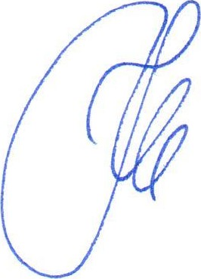
Nur-Sultan
Chairman
K.Yu. Noskov

