REGIONAL COMMONWEALTH IN THE FIELD OF COMMUNICATIONS (RCC)
BOARD OF COMMUNICATIONS ADMINISTRATIONS HEADS COORDINATION COUNCIL OF THE CIS MEMBER-STATES ON THE INFORMATIZATION AT THE RCC

Decision № 55/25-22
16-17 September 2019 Protocol №55/25
On the election of the leadership of the RCC Executive Committee
Guided by the Regulation on the procedure for holding a competition for the post of the General-Director of the Executive Committee of the Regional Commonwealth in the field of Communications and his deputies, approved by the Decision of the RCC Board of the CAs Heads №23/15 of 06/29/2000, after hearing information on the competition for the election of the General-Director of the Executive Committee of the Regional Commonwealth in the field of Communications, having considered the decision of the tender committee on this issue

The Heads decided:
- To elect Mukhitdinov Nurudin Nasretdinovich as the General-Director of the Executive Committee of the Regional Commonwealth in the field of Communications.
- To charge the Chairman of the RCC Board of the CAs Heads with the General-Director of the Executive Committee of the Regional Commonwealth in the field of Communications Mukhitdinov Nurudin Nasretdinovich an employment contract valid until December 31, 2023.
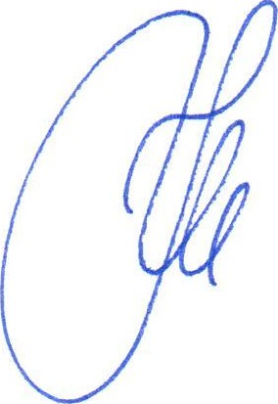
Nur-Sultan
Chairman
K.Yu. Noskov

