REGIONAL COMMONWEALTH IN THE FIELD OF COMMUNICATIONS (RСCC)
BOARD OF COMMUNICATIONS ADMINISTRATIONS HEADS COORDINATION COUNCIL OF THE CIS MEMBER-STATES ON THE INFORMATIZATION AT THE RCC

Decision № 55/25-12
16-17 September 2019 Protocol №55/25
On the preparation of a draft Memorandum on the interaction forms of the countries of the RCC members on postal security issues
Having heard information on this issue, recognizing the importance of improving the work of postal security services in the administrations of the countries of the RCC members, the introduction of postal security standards that meet the recommendations of the UPU, establishing contacts and maintaining links between postal administrations in the protection of international mail from unlawful attacks, noting the need to improve the forms and methods of joint activities of the countries of the RCC members aimed at increasing the effectiveness of jointly conducted measures to protect international postal exchange, guided by the UPU international security standards S58 (General Security Measures) and S59 (Security of exchange offices and international airmail), taking into account the importance of the Memorandum on the interaction forms of the postal security units, adopted at the working meeting on November 29th 2007,
The Heads Decided:
- Approve the activities of the Postal Communications Commission and the Postal Operators Board of the Russian Federation for the past period.
- Instruct the Postal Communications Commission, the RCC Postal Operators Board together with the Executive Committee of the RCC:
- prepare a draft Memorandum on the forms of interaction between the countries of the RCC members on postal security issues, based on the Memorandum on the forms of interaction between the postal security units of postal administrations, members of the RCC PSAG (Postal Security Action Group), adopted at the working meeting on November 29th, 2007,
- submit a draft Memorandum on the forms of interaction between the countries of the RCC members on postal security issues for consideration at the next joint meeting of the RCC Board of the CAs Heads and the Coordination Council.
З. Consider it appropriate for the RCC Postal Communications Commission and the RCC Postal Operators Board to continue:
- participation in regional seminars held by the UPU IB together with the PostEurop Association on postal security issues aimed at combating "dark mail" and protecting the income of designated postal operators of the RCC,
- development of joint solutions to problems related to the transport of mail, integration of the logistics network, simplification of customs procedures, work to improve postal security in accordance with the international security standards UPU S58 (General Security Measures) and S59 (Security of exchange offices and international airmail).

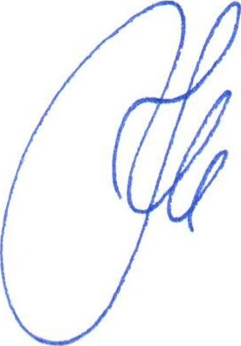
Nus-Sultan
Chairman K.Yu. Noskov

