REGIONAL COMMONWEALTH IN THE FIELD OF COMMUNICATIONS (RCC)
BOARD OF COMMUNICATIONS ADMINISTRATIONS HEADS COORDINATION COUNCIL OF THE CIS MEMBER-STATES ON THE INFORMATIZATION AT THE RCC

Decision № 55/25-11
16-17 September 2019. Protocol №55/25
On the implementation of the priority activities of the participants of the RCC CAs on the implementation of the decisions of the 26th UPU Congress
Noting the importance of the 26th Congress of the Universal Postal Union for the global postal community, which defined the strategic directions for the development of the postal sector for 2017-2020, recognizing that the Universal Postal Union provides assistance and support to the RCC in its activities. With financial and technical support of the UPU International Bureau the RCC Executive Committee jointly with the RCC seminars in priority areas of postal development, considering that the decisions of the Congress reflected the common proposals of the RCC CAs on the development of postal infrastructure, development of financial services, improving the quality of postal services using modern information technologies, improvement of settlements, guided by the Decision of the RCC Board of the CAs Heads and the Coordination Council №53/24-7.1 from October 9-10, 2018, Ashgabat, Turkmenistan,
The Heads Decide:
- Instruct the RCC Commission on Postal Communications and the RCC Postal Operators Board to continue coordinating and monitoring the implementation of promising areas of activity for the implementation of decisions of the 26th UPU Congress for 2017-2020.
- Consider it appropriate for the RCC Commission on Postal Communications and the RCC Postal Operators Board to provide assistance and support to RCC members in implementing the decisions of the 26th UPU Congress.
З. Instruct the RCC Commission on Postal Communications and the RCC Postal Operators Board to report to the RCC Board of the CAs Heads on progressive achievements in the implementation of measures to implement the decisions of the 26th Congress, as necessary.

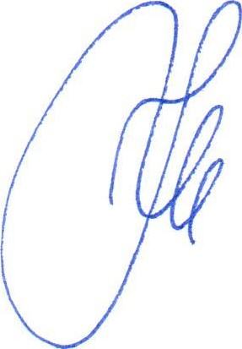
Nur-Sultan
Chairman
K.Yu. Noskov

